Project Design Phase-II

Data Flow Diagram & User Stories

|  |  |
| --- | --- |
| DATE | 27 OCT 2022 |
| PROJECT NAME | Web Phishing Detection |
| TEAM ID | PNT2022TMID34399 |
| MAXIMUM | 4 MARKS |

Data Flow Diagrams:

A Data Flow Diagram (DFD) is a traditional visual representation of the information flows within a system. A neat and clear DFD can depict the right amount of the system requirement graphically. It shows how data enters and leaves the system, what changes the information, and where data is stored



Data Flow Diagram

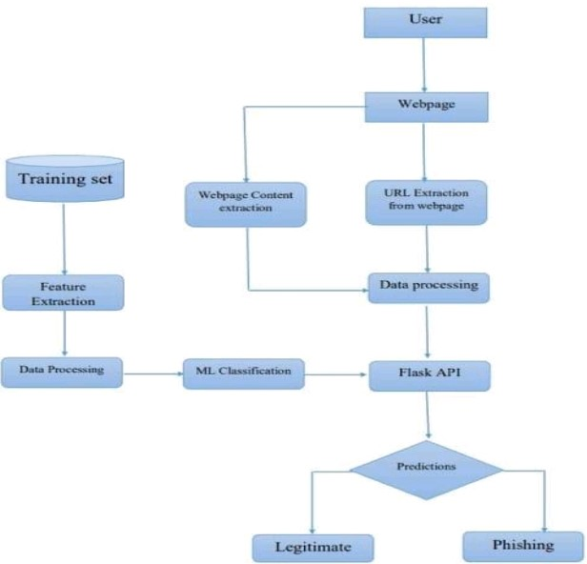

User Stories

Use the below template to list all the user stories for the product

